Farmers ZSOA
Zurich Services Oriented Architecture

Territory Code
Technical Design

Version 1.2



Farmers Service Competency Center

Copyright Zurich Financial Services

Document History

Version | Date | Author | Comment
1.1 | 02/18/2008 | Emmanuel Ameh | Initial Draft
1.2 | 03/18/2008 | Emmanuel Ameh | Changes in design by Charlie, Jagadish,Kamalakar

Table of Contents
1 About this Document 5
1.1 Introduction 5
1.2 Intended Audience 5
1.3 How this document is organized 5
1.4 Reference Architecture 5
1.5 Service Overview 7
2 Orchestration Layer Components 9
2.1 ESB Components 9
2.1.1 ALSB 9
2.2 Client interface 10
2.3 Message flow 10
2.4 Transformations 11
2.5 Routing 11
3 Service Enablement Layer Components 12
3.1 Interface 12
3.1.1 Functionality Required 12
3.1.2 Inputs 12
3.1.3 Outputs 12
3.1.4 Faults 12
3.1.5 Data Modifications 13
3.1.6 Logical Flowchart 13
4 Implementation Layer Components 14
4.1 Class Diagram 14
4.2 Mainframe Programs 15
4.2.1 Program Name 15
4.2.2 Region 15
4.2.3 Linkage section 15
4.2.4 Procedure Division declaration 15
4.3 EJB’s 15
4.4 Database\Stored Procedures 15
5 Functional\Non-functional requirements 16
5.1 Functional 16
5.1.1 Feature specifications 16
5.2 Non-functional 16
5.2.1 Security 16
5.2.2 Logging 16
5.2.3 Monitoring 16
5.2.4 Business exception handling 16
5.2.5 Response time 16
5.2.6 Concurrent Users 16
5.2.7 Availability 16
6 Business Contacts 17

About this Document

Introduction
This document describes the design artifacts and implementation model of the TerritoryCode Service. Although external systems (upstream and downstream) are referenced in this document, their detailed behavior falls outside the scope of this document. Overall system requirements are covered in the requirements and use case document and, therefore, also fall outside the scope of this document.

Intended Audience
This document is intended for the team members who will be responsible for development of this service.

How this document is organized
The design for the TerritoryCode Service is presented in 4 areas of interest as outlined below.
- Orchestration Layer Components: Presents the services, components and information pertinent to this level. The primary focus here is on the Enterprise Service Bus and the activities carried out there.
- Service Enablement Layer Components: Describes the design and pertinent aspects needed to develop the atomic services as well as any other aspects implemented at this level.
- Implementation Layer Components: This deals primarily with backend or legacy data sources and the design to follow in exposing their services to the enterprise.
- Functional\Non-functional Requirements: This section outlines the functional and non-functional requirements identified for this service.

Reference Architecture
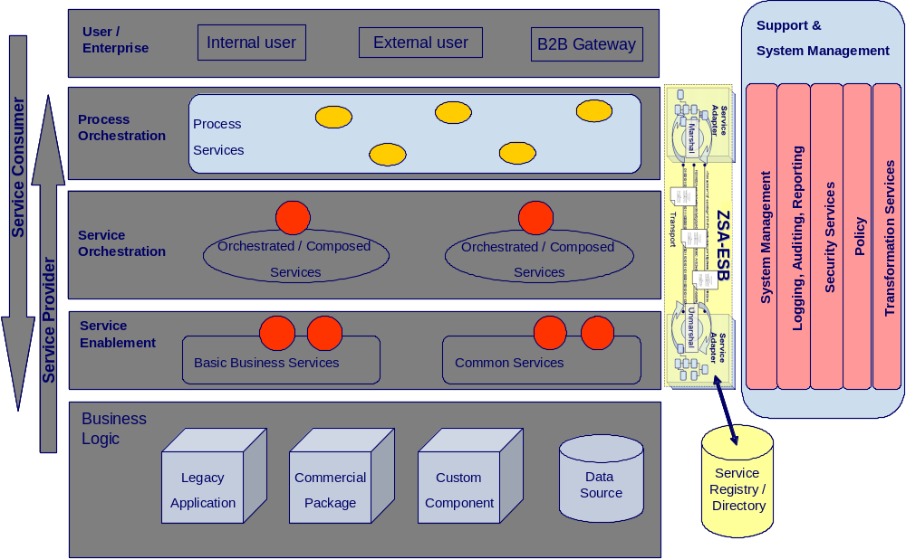

As shown in the above diagram, the TerritoryCode service will follow the reference architecture defined in the “ZSA_Tech_Ref_Architecture” document.
The special implementation is required for security and transformation for providing web services to the (Consumer). The detail of the implementation is explained below:
The end-to-end flow will follow the steps shown in the diagrams:

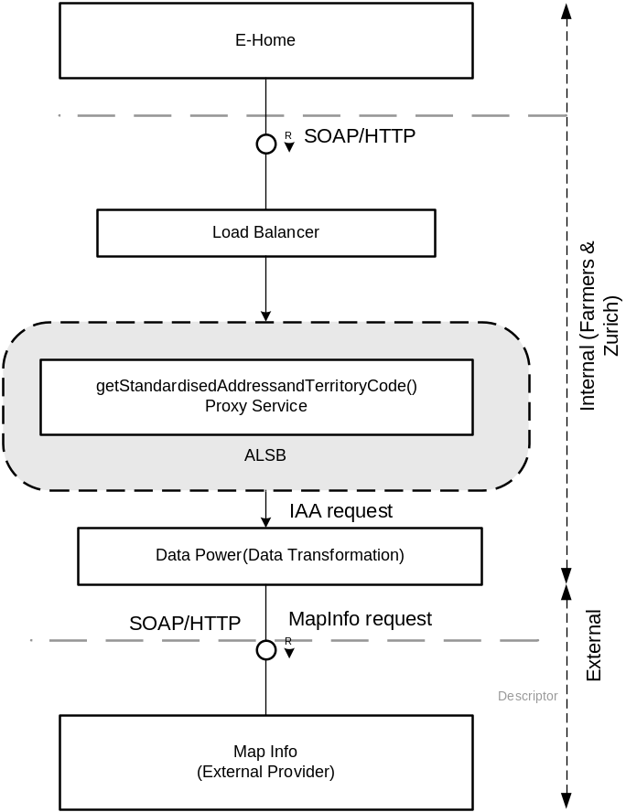

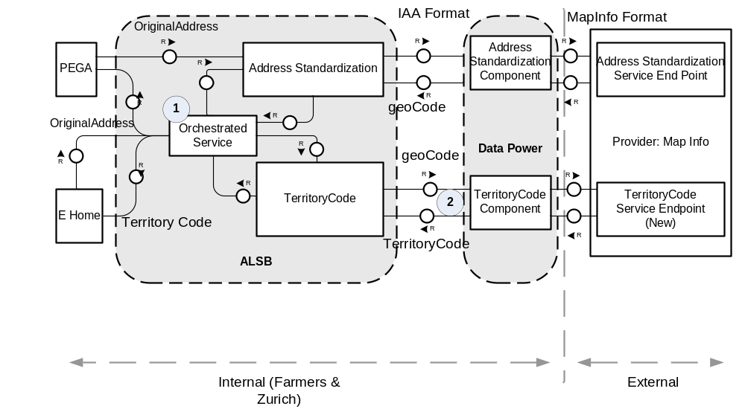
The steps in the above diagram are explained below:
- Both PEGA & E Home Consumer sends original address (Nonstandardised address) as a request to orchestrated proxy service and gets a common response which contains: Standardised address, Geo Code, Territory code. The consumer needs to take whatever needed and ignore all other elements.
- The territory code from provider will be retrieved by sending geocode in a request. The data power component does the transformation required between IAA format and MapInfo format.

Service Overview
This service will request and return the Territory Code from the external provider.
The following diagram gives a high level overview of the service’s structure. As per the reference architecture, Party Object has implementation components in the Service Enablement, Atomic, and Orchestrated layers.
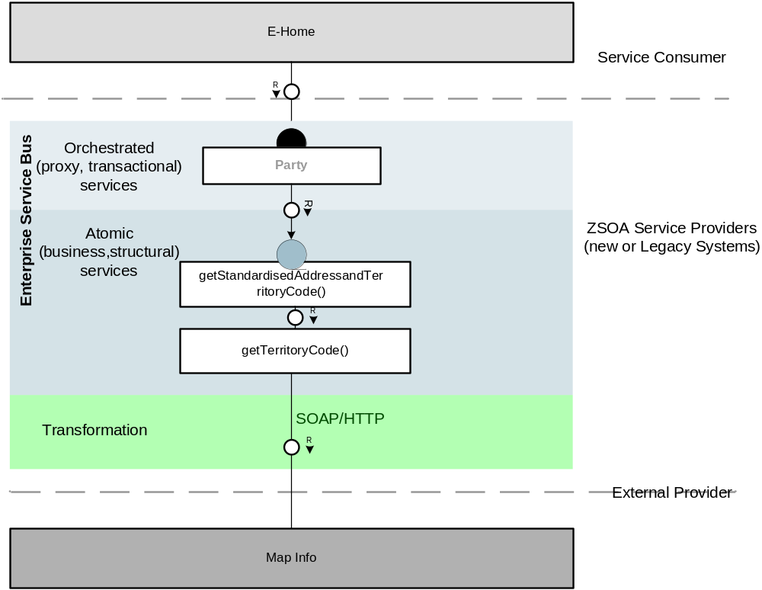

Map Info is going to create new service end point for providing territory code for a requested geocode. We need Service Contracts for the new service endpoint from Map Info.
The Farmers Ohio Territory Data is available at the following data path on miplatform (Development Platform) :
EVAL; FARMERS_PLA//Fire
You will need to replace the data path in the XML Request to the Directory Service to point to the above path. The Envinsa Directory Service URL on miplatform to access the data is http://miplatform.mapinfo.com/Directory/services/Directory

Orchestration Layer Components

ESB Components

ALSB

2.1.1.1 Business Service
This section contains the detail necessary to define the business service in the ESB.

General Configuration
Service Name | TerritoryCode
Description | The purpose of TerritoryCode service is to retrieve territory code for a given geocode from external provider.
Service Type | Web service
Transport Configuration
Protocol | HTTP
Load balancing | Yes
Endpoint URI | http://services.farmersinsurance.com/services/<<tbd>>
Retry count | 2
Retry interval | 30 seconds
HTTP Transport Configuration
Timeout | Default to server
HTTP Request Method | Post
Authentication | No
Follow HTTP redirects | Yes
SOAP Binding Configuration
Enforce WS-I Compliance | Yes

2.1.1.2 Proxy Service
This section contains the detail necessary to define the proxy service in the ESB.

General Configuration
Service Name | GeographicAddressingService
Description | This services fronts the primary business service
Service Type | WSDL Web Service
Proxy Service Provider
Protocol | HTTP
Endpoint URI | http://services.farmersinsurance.com/services/<<tbd>>_proxyService
Get All Headers | Yes
Headers
HTTP Transport Configuration
Authentication | No
Message Level Security Configuration
Custom Authentication | No
Operation Selection Configuration
Enforce WS-I Compliance | Yes
Selection Algorithm | SOAP Body Type

2.1.1.3 WSDL
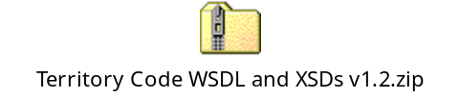

Client interface
A consumer will access this service via a WS-I v1.0-compliant web service invocation. This service uses the wrapped document literal binding style. The request/response messages are in IAA canonical format and the consumer has the responsibility to map the XML message structure to their internal format.

Message flow
Message Flows are the definitions of AquaLogic Service Bus proxy services. Pipelines (Request and Response pipelines), branch nodes, and route nodes define the implementation of AquaLogic Service Bus proxy services. There will be a Pipeline Pair required to handle the request and response, and Route node required and there is no requirement for branch nodes. ALSB provides a route node is used to perform request/response communication with Proxy service and Address Standardization business service running on the MapInfo. The route node supports conditional routing as well as request and response transformations.

Transformations
The transformation may not be required for the internal applications used by agents, customers and internal departments but the real time transformation is required to transform the Vendor XML to the ZAA XML which extend from IAA schema and vice versa for external vendors.
Data transformation is the mapping of data from one format to another. DataPower transforms messages from IAA format to MapInfo format. It uses the Xquery, XSLT transformation and XPath language for data composition and transformation for service endpoints. Data power supports data mapping that uses XQuery and the eXtensible Stylesheet Language Transformation (XSLT) standards. You need transform IAA service request (IAA message) to MapInfo service request

Routing
None

Service Enablement Layer Components

Interface
The TerritoryCode service is to be the result of building a service layer to interact with new third party vendor provider

Functionality Required
A new service is to be enabled under Party Package in IAA. The WSDL files to be implemented for this service is located in section 2.1.1.3. Service enabling this new calling program will require mapping of the ZIAA canonical model to the existing inputs and outputs. The following table shows the native input\output element to ZIAA WSDL mapping
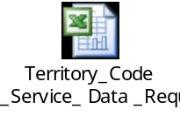

Inputs
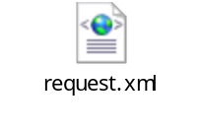
Use Case Parameter | Type | Element | Schema
Original Address | String

Outputs
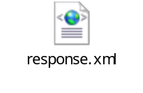

Use Case Parameter | Type | Element | Schema
Geo Code Point  Territory Code Point | String  String

Faults

U.C. Parameter | Element | Type | Schema
Technical Error | errorMessageType | String | (ZSOA.xsd)
Business Error | errorState | String | (ZSOA.xsd)

Data Modifications
Identify any data modifications which need to occur in the service enablement layer.

Field Name | Modifications

Logical Flowchart

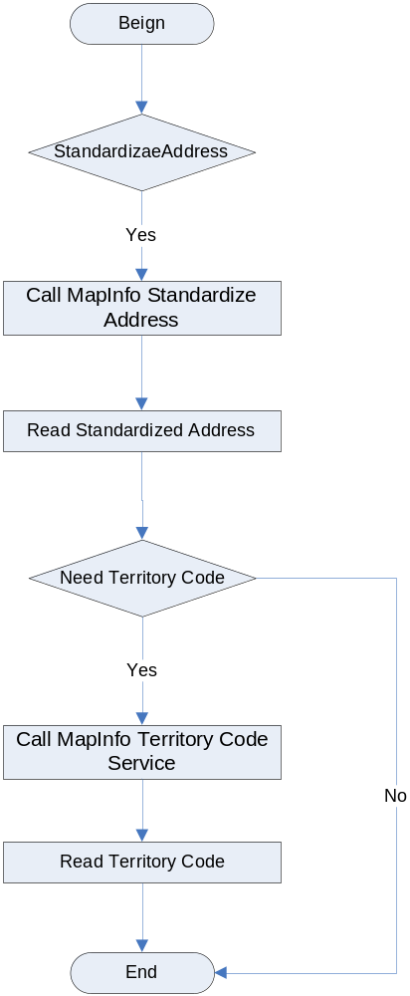

Implementation Layer Components

Class Diagram
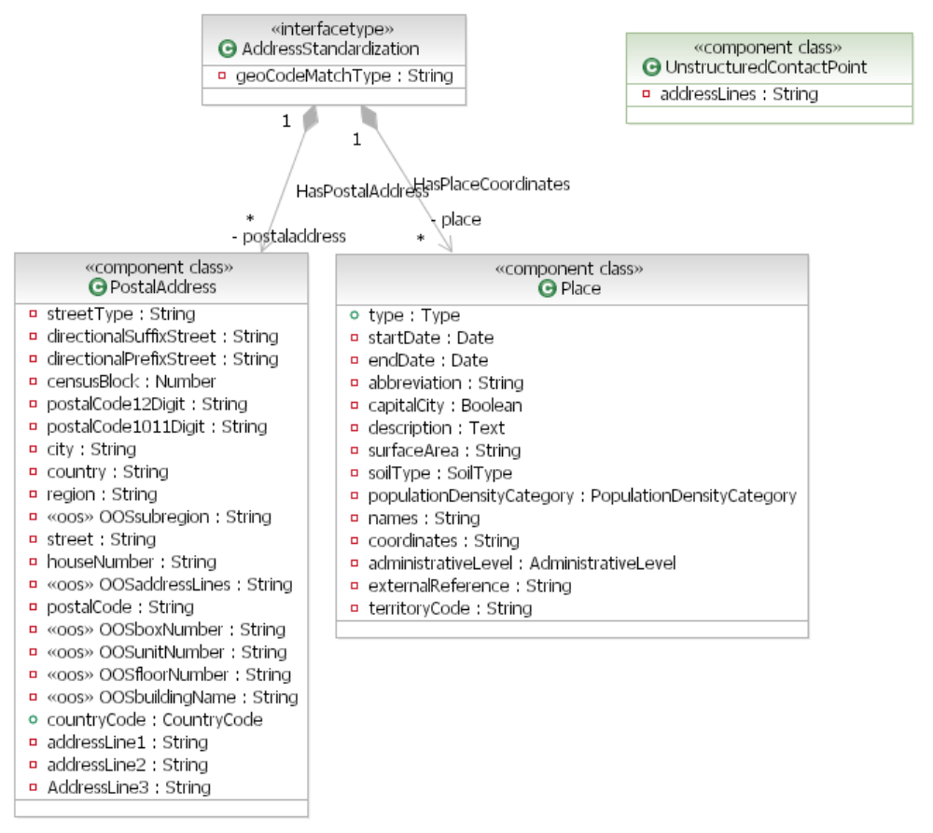

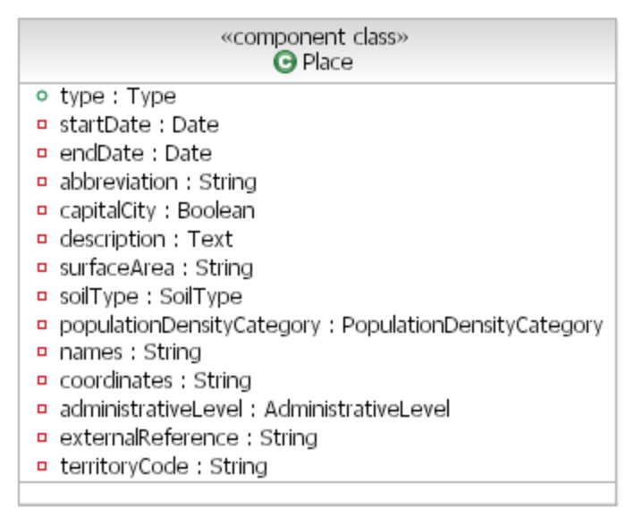

Mainframe Programs
<<None>>

Program Name
<<None>>

Region
<<None>>

Linkage section
<<None>>

Procedure Division declaration
<<None>>

EJB’s
<<None>>

Database\Stored Procedures
<<None>>

Functional\Non-functional requirements

Functional

Feature specifications

Non-functional

Security

Logging

Monitoring

Business exception handling

Response time

Concurrent Users

Availability
As far as availability is concerned, EOLS (production) will be available 100% of the time.

Business Contacts
Name | Company | Role | Email address
Emmanuel Ameh | Farmers | Service Modeler | emmanuel.ameh@farmersinsurance.com
Swapna Havnur | Farmers | eHome Solution Design | swapna.havnur@farmersinsurance.com
Goutham Nellutla | Farmers | Program Manager, Farmers Services Competency Center | goutham.nellutla@farmersinsurance.com

